Pariksha – Exam Management System

Entity Relation Diagram

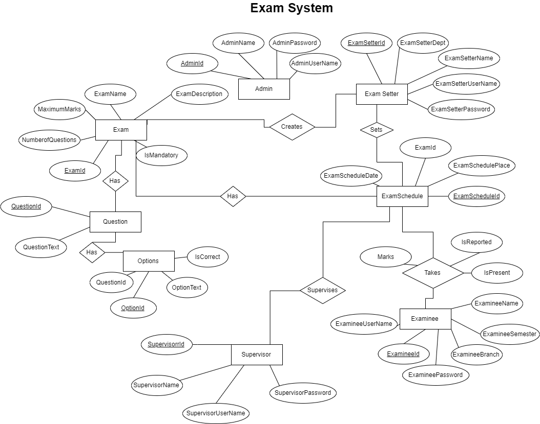

Pariksha – Exam Management System

Database Schema

|  |  |  |  |  |
| --- | --- | --- | --- | --- |
| **Admin** | | | | |
| **Column Name** | **Data Type** | **Size** | **Constraint** | **Reference** |
| AdminId | Integer | 5 | PK |  |
| AdminName | Varchar | 50 | Not Null |  |
| AdminPassword | Varchar | 20 | Not Null |  |
| AdminUserName | Varchar | 30 | Unique,  Not Null |  |

|  |  |  |  |  |
| --- | --- | --- | --- | --- |
| **Exam Setter** | | | | |
| **Column Name** | **Data Type** | **Size** | **Constraint** | **Reference** |
| ExamSetterID | Integer | 5 | PK |  |
| ExamSetterName | Varchar | 50 | Not Null |  |
| ExamSetterPassword | Varchar | 20 | Not Null |  |
| ExamSetterUserName | Varchar | 30 | Unique,  Not Null |  |
| ExamSetterDepartment | Varchar | 20 |  |  |

|  |  |  |  |  |
| --- | --- | --- | --- | --- |
| **Supervisor** | | | | |
| **Column Name** | **Data Type** | **Size** | **Constraint** | **Reference** |
| SupervisorID | Integer | 5 | PK |  |
| SupervisorName | Varchar | 50 | Not Null |  |
| SupervisorPassword | Varchar | 20 | Not Null |  |
| SupervisorUserName | Varchar | 30 | Unique,  Not Null |  |

|  |  |  |  |  |
| --- | --- | --- | --- | --- |
| **Examinee** | | | | |
| **Column Name** | **Data Type** | **Size** | **Constraint** | **Reference** |
| ExamineeID | Integer | 5 | PK |  |
| ExamineeName | Varchar | 50 | Not Null |  |
| ExamineePassword | Varchar | 20 | Not Null |  |
| ExamineeUserName | Varchar | 30 | Unique,  Not Null |  |
| ExamineeSemester | Integer | 2 |  |  |
| ExamineeBranch | Varchar | 20 |  |  |

|  |  |  |  |  |
| --- | --- | --- | --- | --- |
| **Exam** | | | | |
| **Column Name** | **Data Type** | **Size** | **Constraint** | **Reference** |
| ExamId | Integer | 5 | PK |  |
| ExamName | Varchar | 20 | Not Null |  |
| ExamDescription | Varchar | 100 |  |  |
| NumberOfQuestions | Integer | 3 | Not Null |  |
| MaximumMarks | Integer | 4 | Not Null |  |
| ExamineeUserName | Varchar | 30 | Unique,  Not Null |  |
| ExamineeSemester | Integer | 2 |  |  |
| ExamineeBranch | Varchar | 20 |  |  |
| IsMandatory | Bool |  | Not Null |  |
| ExamSetterId | Integer | 5 | FK | ExamSetter |

|  |  |  |  |  |
| --- | --- | --- | --- | --- |
| **ExamSchedule** | | | | |
| **Column Name** | **Data Type** | **Size** | **Constraint** | **Reference** |
| ExamScheduleId | Integer | 5 | PK |  |
| ExamScheduleName | Varchar | 20 | Not Null |  |
| ExamScheduleDescription | Varchar | 100 |  |  |
| ExamScheduleDate | Datetime |  | Not Null |  |
| ExamSchedulePlace | Varchar | 40 | Not Null |  |
| ExamineeUserName | Varchar | 30 | Unique,  Not Null |  |
| ExamSetterId | Integer | 5 | FK | ExamSetter |
| SupervisorId | Integer | 5 | FK | Supervisor |
| ExamId | Integer | 5 | FK | Exam |

|  |  |  |  |  |
| --- | --- | --- | --- | --- |
| **Question** | | | | |
| **Column Name** | **Data Type** | **Size** | **Constraint** | **Reference** |
| QuestionId | Integer | 5 | PK |  |
| QuestionText | Varchar | 100 | Not Null |  |
| ExamId | Integer | 5 | FK | Exam |

|  |  |  |  |  |
| --- | --- | --- | --- | --- |
| **Option** | | | | |
| **Column Name** | **Data Type** | **Size** | **Constraint** | **Reference** |
| OptionId | Integer | 5 | PK |  |
| OptionText | Varchar | 100 | Not Null |  |
| IsCorrect | Bool |  | Not Null |  |
| QuestionId | Integer | 5 | FK | Question |

|  |  |  |  |  |
| --- | --- | --- | --- | --- |
| **Examinee-ExamSchedule** | | | | |
| **Column Name** | **Data Type** | **Size** | **Constraint** | **Reference** |
| ExamineeId | Integer | 5 | PK,FK | Examinee |
| ExamScheduleId | Integer | 5 | PK,FK | ExamSchedule |
| IsReported | Bool |  | Not Null |  |
| IsPresent | Bool |  | Not Null |  |
| Marks | Integer | 4 | Not Null |  |

Prepared By:

Rushi Vachhani

Vivek Shah